China DSL Compliance for Log360
Strengthen cybersecurity and meet China DSL compliance with Log360.
Region: China | Type: Incident Management | Category: Compliance | Pricing: Free

Overview
The China DSL compliance extension in Log360 helps organizations meet China's Data Security Law (DSL, effective September 2021), a comprehensive data regulatory regime establishing data classification, graded protection, and cross-border transfer restrictions for all organizations processing data in China by providing centralized log management, data access auditing, and security monitoring. The platform supports China DSL requirements for data classification and grading, security management systems, monitoring and early warning, data risk assessment, incident response, and cross-border data transfer controls.
For Data Classification and Graded Protection (Arts. 21-22), Log360 audits database schema changes, DML operations, file system modifications, and cloud storage activity to provide visibility across classified data assets and support graded access controls. To address Data Security Management System (Arts. 27-29), the platform tracks GPO changes, policy management events, M365 directory and role management, and user auditing to demonstrate active governance over data security. The extension also supports Data Security Monitoring and Early Warning (Arts. 23-26) by providing capabilities that aggregates threat detections from endpoint security, Unix threat reports, network attack logs, and cloud security incident alerts to provide real-time monitoring and early-warning capabilities.

Key Features
- Privileged Access and Administrative Oversight (Art. 27): Log360 tracks administrative logon activity, privilege escalations, and critical system modifications across Active Directory, Unix, and cloud environments to ensure strict accountability for high-privileged accounts managing sensitive data.
- Data Processing Activity Security (Arts. 31-35): Log360 monitors logon events, failed authentications, database access, network device activity, and firewall events to provide end-to-end data processing security visibility.
- Cross-Border Data Transfer Security (Art. 36): Log360 monitors AWS IAM activity, user access patterns, S3 file changes, unauthorized access attempts, and network security groups to detect and audit potential cross-border data movements.
- Data Security Incident Reporting (Art. 41): Log360 detects incidents through Microsoft Defender alerts, network attack reports, cloud security incident logs, and threat feeds from FireEye, Trend Micro.
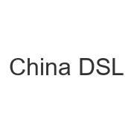
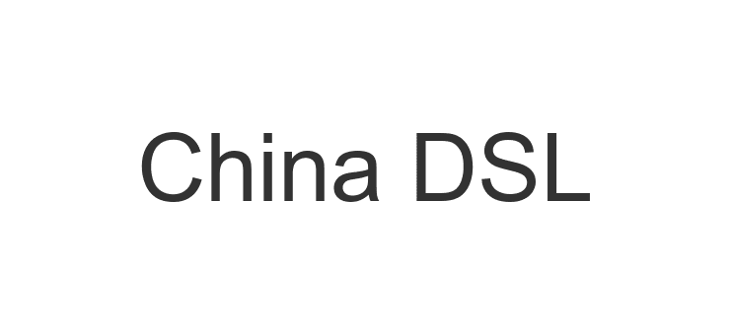
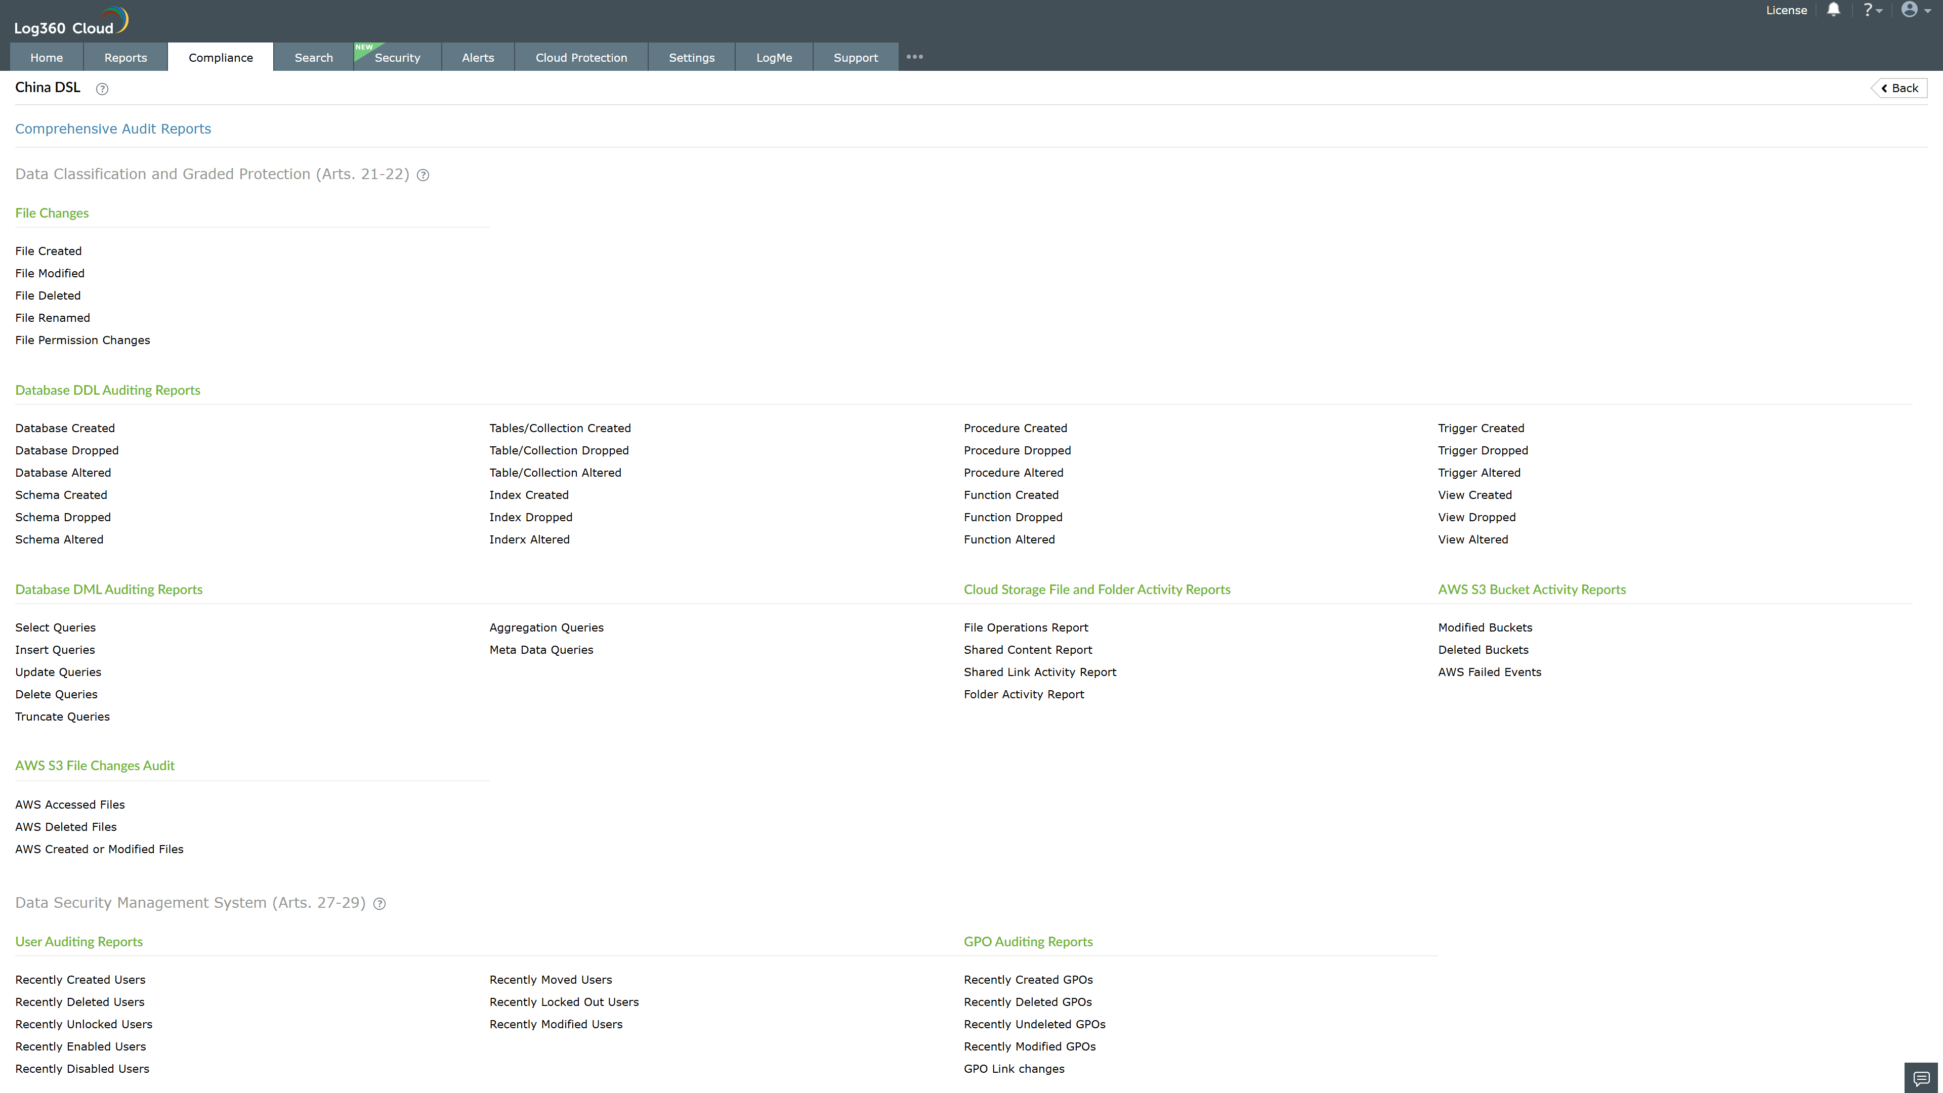
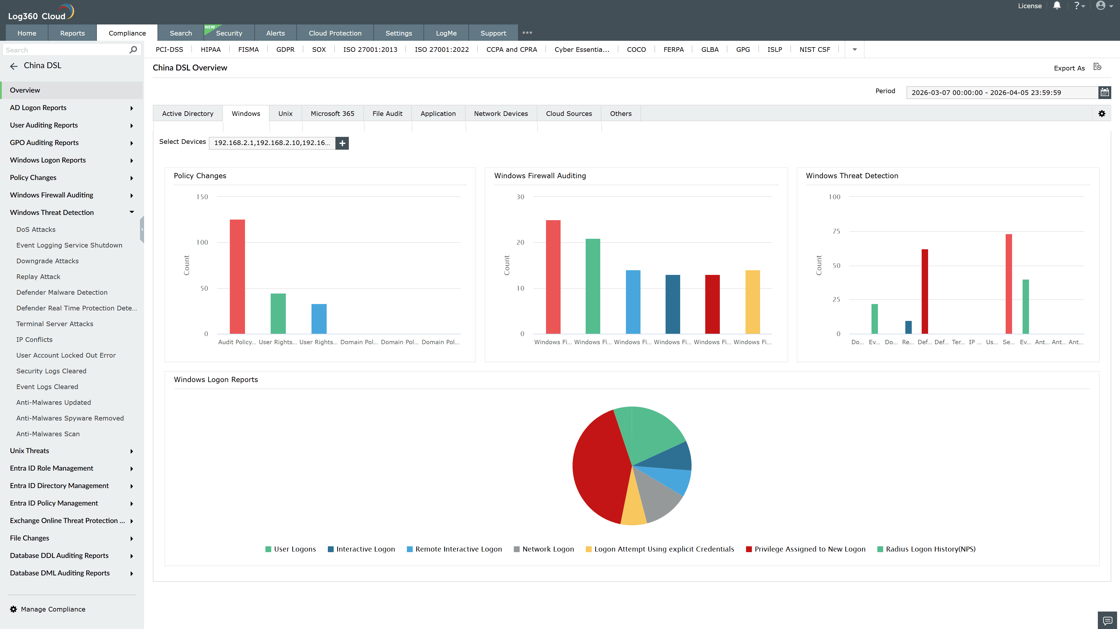
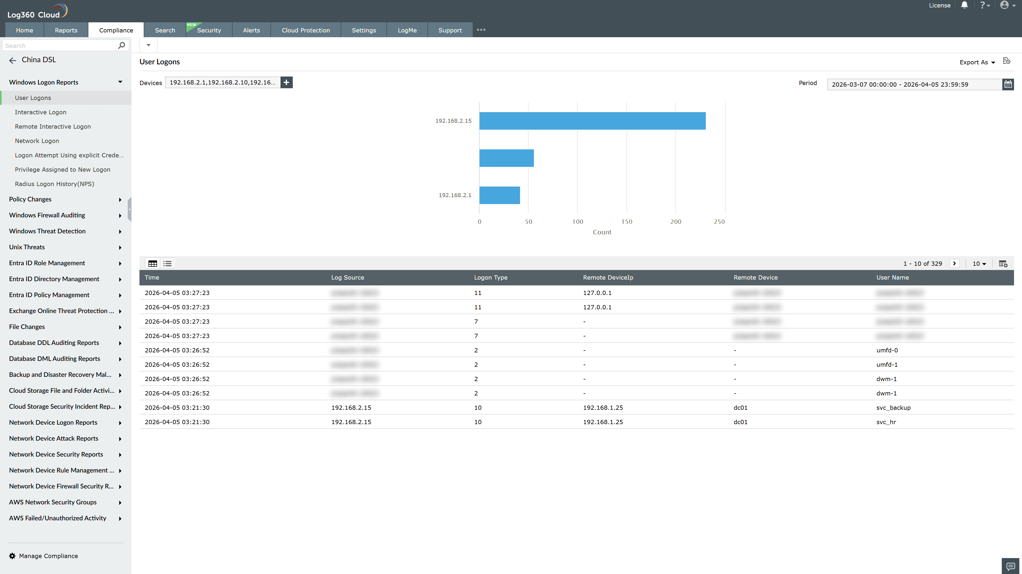
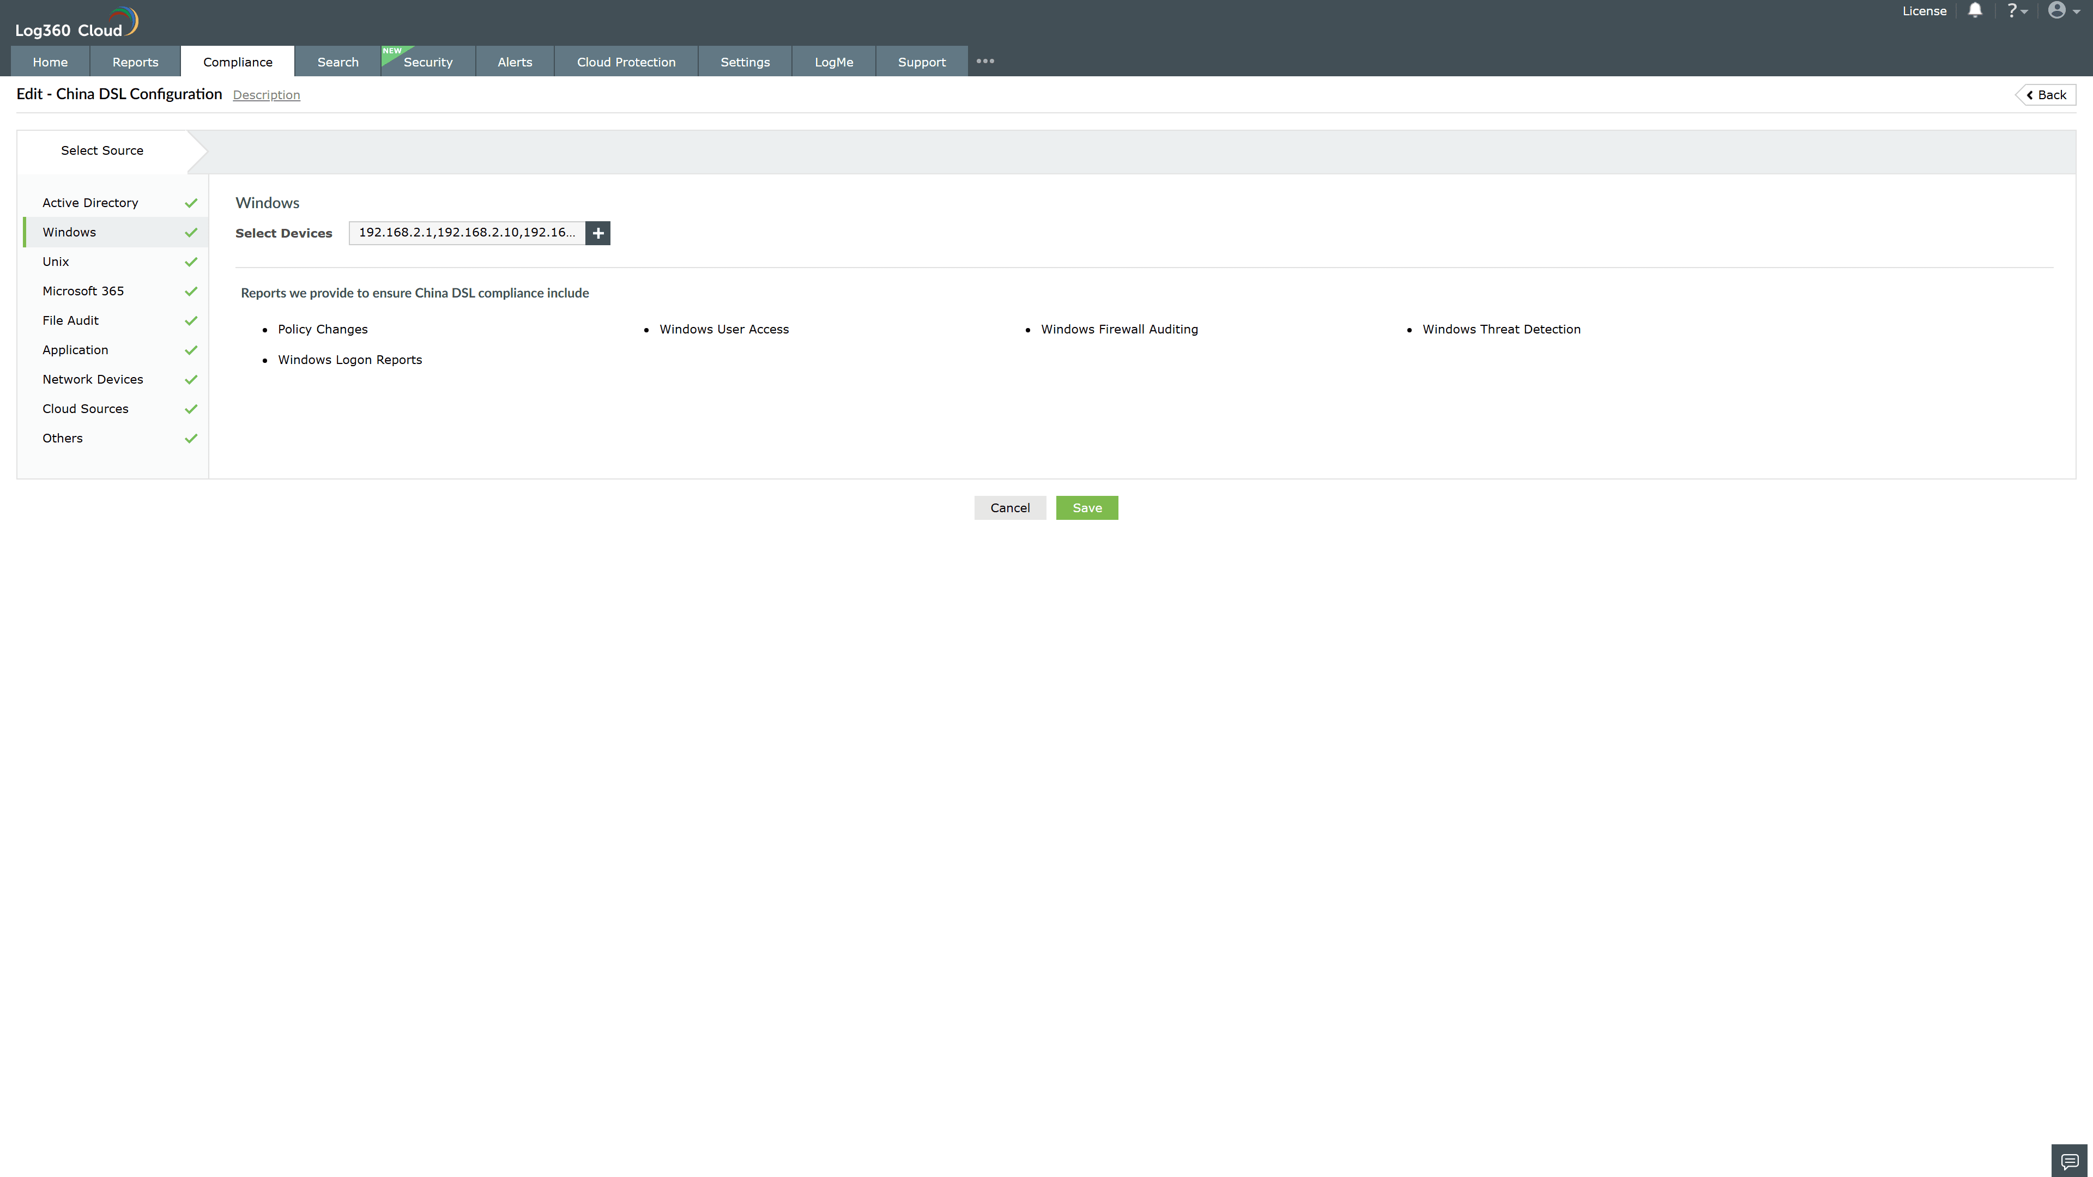
Valid Submission : Yes
Supported Editions : Free, Basic, Standard, Professional, MSSP
Help Document : https://www.manageengine.com/log-management/help/integrations/compliance-extensions.html
Help Video : Not provided
Tags : Log360, Compliance, Privacy monitoring, Data privacy, Regulatory compliance
Supported DCs : US, IN, JP, CA, AU, UK and EU
Privacy Policy:
Terms of Service:
Release Notes:
Predefined reports for the China DSL.

